REVIEW 1 – PROBLEM FORMULATION
Resilient Multi-Peer File Distribution & Recovery Engine
Team 13 | Theme 3 | Guide: Ms. Pooja P Shettar
Field | Student Entry
Team No. | 13
Theme No. | 3
Project Title | Resilient Multi-Peer File Distribution & Recovery Engine
Guide Name | Ms. Pooja P Shettar

Team Members
Sl. No. | Student Name
1 | Vineet S Kulkarni
2 | Manasa B Vasare
3 | Mahadev Pawar
4 | Arihant A Narayankar

1. Motivation
In a multi-peer file distribution environment, a file may be divided into smaller portions and distributed among multiple participating peers for storage and transfer. Successful retrieval of the complete file therefore depends on the availability and accessibility of the required portions across the participating peers.
In practical distributed environments, peers may become temporarily unavailable due to process termination, network interruption or other failures. Such unavailability can make required file portions inaccessible and may interrupt file retrieval or prevent successful reconstruction. Repeatedly depending on the same unavailable peer can further increase recovery time and communication overhead.
The proposed Resilient Multi-Peer File Distribution & Recovery Engine aims to study and develop a system that can continue file distribution and retrieval despite defined peer failures. The project focuses on identifying unavailable data, obtaining the required information from available participating peers, verifying recovered data and reconstructing the original file.
The project integrates foundational Computer Science concepts from Design & Analysis of Algorithms (DAA), Computer Networks, Operating Systems, Distributed Systems, Database Management Systems (DBMS) and Object-Oriented Programming (OOP) into a practical fault-tolerant computing problem.

2. Project Objectives
- To develop a multi-peer file distribution system capable of dividing and distributing file data among participating peers.
- To enable the system to identify unavailable or failed peers and determine the impact on ongoing file retrieval.
- To provide a recovery mechanism that can retrieve missing file data from available surviving replicas on participating peers and reconstruct the original file.
- To verify recovered data and successfully reconstruct the requested file after supported peer failures.
- To study the behaviour of the system under different controlled peer availability and failure conditions.

3. Foundation Course Integration
The following foundation courses are expected to contribute meaningful technical depth to the project.
Sl. No. | Foundation Course | Broad Concepts / Areas Expected to be Applied | Role
1 | Design & Analysis of Algorithms (DAA) | Chunking, distribution strategy, replica/source selection, searching, ordering and reconstruction. | Supporting
2 | Computer Networks | Peer communication, data transfer, addressing, connection management and network failures. | Dominant
3 | Operating Systems | Processes, process lifecycle, file handling, resource management and process failure. | Dominant
4 | Distributed Systems | Peer-based resource sharing, replication, fault tolerance, availability and failure handling. | Dominant
5 | Database Management Systems (DBMS) | Metadata storage, chunk-to-peer mapping, peer status and efficient metadata lookup. | Supporting
6 | Object-Oriented Programming (OOP) | Modular system design using components such as Peer, Chunk, Transfer and Recovery. | Supporting

4. Conceptual Workflow / System View
The conceptual workflow begins with file input and preparation, followed by distribution across participating peers. Peer availability is monitored. If all required data is available, the system retrieves it directly; otherwise, it detects missing data, recovers it from an available surviving replica, verifies the recovered data and reconstructs the original file.
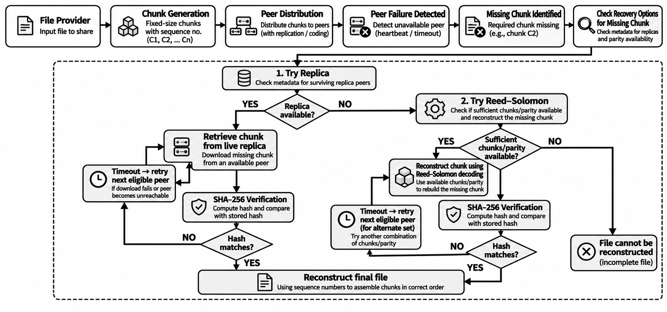
Fig. 1. Conceptual workflow recreated from the Gate 0 project synopsis (page 2).

5. Broad Project Scope

5.1 Broadly In Scope
# | What is in scope? | Foundational Subject (plain meaning) | Planned Technique (what the system does) | Purpose
1 | File chunking | Design & Analysis of Algorithms (organizing and processing data) | Split file into equal-size pieces and number them. | Create C1, C2 … Cn.
2 | Multi-peer distribution | DAA + Computer Networks (organize + communicate) | Assign chunks one-by-one to peers; keep required copies. | Spread chunks across peers.
3 | Peer discovery / communication | Computer Networks + Distributed Systems (find and connect peers) | Maintain peer list and use TCP connections. | Find peers and transfer chunks.
4 | Peer failure simulation | Operating Systems + Distributed Systems (run and monitor peers) | Periodic 'I am alive' message + timeout. | Detect an unavailable peer.
5 | Missing-chunk detection | DAA + DBMS (find information quickly) | Look up the chunk ID in stored metadata. | Find the missing chunk and its available copies.
6 | Chunk recovery + retry | Distributed Systems + Computer Networks (recover across peers) | Retrieve a missing chunk from an available surviving replica; retry another eligible peer on timeout. | Recover the missing chunk.
7 | Integrity + reconstruction | DAA + DBMS (track order + stored values) | SHA-256 check, then join chunks in their original order. | Verify and rebuild the file.
8 | Recovery / performance evaluation | OS + Networks + Distributed Systems (run and measure failures) | Repeat defined failure scenarios and measure results. | Measure recovery, detection, data transfer and retries.

5.2 Out of Scope
# | Out-of-Scope Item | Reason
1 | Advanced Erasure Coding | Reed-Solomon and other coding-based recovery techniques are proposed for future enhancement but are not implemented in the current prototype.
2 | Dynamic Peer Scaling | The prototype uses a predefined number of peers for controlled distribution, failure and recovery experiments.
3 | Resumable Partial-Chunk Transfer | Interrupted transfers are handled by retrying the complete chunk rather than resuming from the interrupted byte position.
4 | Multiple Simultaneous Peer Failures Beyond Defined Scenarios | Testing is limited to controlled failure scenarios so recovery behaviour can be measured consistently.
5 | Advanced Security and Access Control | Authentication, authorization, encryption and enterprise-level security mechanisms are outside the core file distribution and recovery problem.
6 | Graphical / Mobile User Interface | The project focuses on the underlying distribution, failure detection, recovery, verification and reconstruction engines rather than interface development.

6. Feasibility & Constraints
Aspect | Project Assessment
Feasibility within scope | Feasible with controlled scope and a limited number of participating peers.
Required computing / resources | Student laptops/PCs, local network connectivity, file storage, development environment, version-control facility and multiple peer processes or systems for controlled experimentation.
Prerequisite knowledge | Design & Analysis of Algorithms (DAA), Computer Networks, Operating Systems, Distributed Systems, DBMS and Object-Oriented Programming (OOP) concepts.
Major constraints / limitations | Limited project duration, limited number of available machines/peers, controlled laboratory environment, bounded failure scenarios and the need to keep the implementation manageable within a mini-project.
Use of existing libraries / tools | Existing libraries and tools may be used for peripheral functions such as basic file handling, communication support and data verification. The core peer distribution, failure handling, recovery and reconstruction logic will be designed and studied by the team.
Overall feasibility | Feasible with controlled scope and a limited number of participating peers.

